ANNUAL GENERAL MEETING
Notice is hereby given that the 2024 Annual General Meeting of the League will be held at the Great Barr Hotel, Pear Tree Drive, Newton Road, Great Barr, Birmingham B43 6HS on Saturday 30th November 2024 commencing at 11:00.
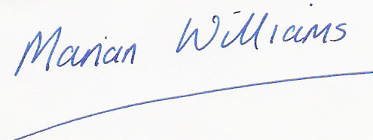

Marian Williams
League Administrator

The business of the AGM shall be in accordance with rule 11.1 & 11.2 of the league’s constitution.

For clarification, all motions, including nominations for Officers or the Management Group, submitted by Clubs or Composite Teams must be sent in writing to the league administrator by 09:00 on 1st November 2024 at the latest. They must be submitted on club headed notepaper signed by two officers of the Club, or the YDL representative and one other officer of the Club, with the agreement of the Club’s Management Committee.

Motions must be supported by at least 5 additional Clubs or Composite teams. (Composite teams are considered to be one club, and any resolutions must have the agreement of all members of the composite.)

The following positions are due to be elected this year:
- Chair - to serve to 2028
- Southern Area Co-ordinator (currently Stuart Horsewood) – to serve to 2026
- Northern Area Co-ordinator (currently Nicola Thomson) – to serve to 2026
- Midlands Area Co-ordinator (currently unfilled) – to serve to 2025
- There are three additional vacancies for general committee members; these positions are currently filled by
Tim Soutar (to serve to 2026)
Mick Bond (a casual vacancy, with remaining term to serve to 2025)
Dave Paver (a casual vacancy, with remaining term to serve to 2025)

All the above positions will require a nomination for election.

Further information will be sent out and added to the UKYDL website in due course.

